**Project: jenkins-terraform-docker-nginx-project**

**🎯 Objectives**

This project demonstrates how to use **Jenkins pipeline** to automate the provisioning of a **Dockerized NGINX container** using **Terraform**.  
The Jenkins pipeline pulls Terraform configuration from this GitHub repository, initializes Terraform, and deploys an NGINX Docker container on the Jenkins host.

📦 Project Overview  
This repository contains:  
✅ Terraform configuration file (main.tf) to define a Docker container running NGINX  
✅ Jenkins pipeline (Jenkinsfile) that:

* Clones this repository
* Runs Terraform to deploy the NGINX container
* Verifies that the container is running

**⚙️ How It Works**

1. **Jenkins Pipeline**  
   Jenkins pulls the project from GitHub and executes the Jenkinsfile
2. **Terraform Execution**  
   Inside the pipeline, Terraform is initialized and applied from the terraform/main.tf file
3. **Docker Provider**  
   Terraform uses the kreuzwerker/docker provider to interact with the local Docker daemon
4. **NGINX Deployment**  
   Terraform pulls the nginx:latest image and starts an NGINX container named nginx
5. **Port Mapping & Verification**  
   The container’s port 80 is mapped to host port 8081, making the service accessible externally.  
   Jenkins runs docker ps to confirm that the NGINX container is running successfully.
6. **Live App Access**  
   The NGINX welcome page can be accessed at: [**http://localhost:8081**](http://localhost:8081/)

**⚙️ Prerequisites**

Make sure the following are installed on your Jenkins server (master):  
✅ Jenkins (with pipeline plugin)  
✅ Terraform  
✅ Docker  
✅ Git

* **Check docker version after installing:**

root@jenkins-server ~ via v17.0.13 ✖ docker --version

Docker version 28.3.3, build 980b856

* **Check Terraform version after installing:**

root@jenkins-server ~ via v17.0.13 ➜ terraform -version

Terraform v1.13.0

on linux_amd64

✅ GitHub holds Terraform configuration file (main.tf) to define a Docker container running NGINX:

**main.tf**

terraform {

required_providers {

docker = {

source = "kreuzwerker/docker"

version = "~> 3.0.1"

}

}

}

provider "docker" {}

# Pull NGINX Docker image

resource "docker_image" "nginx" {

name = "nginx:latest"

}

# Run NGINX container

resource "docker_container" "nginx" {

name = "nginx"

image = docker_image.nginx.name

ports {

internal = 80

external = 8081

}

}

✅ Jenkins pipeline:

pipeline {

agent any

environment {

TERRAFORM_DIR = 'terraform'

CONTAINER_NAME = 'nginx'

HOST_PORT = '8081'

}

stages {

stage('Checkout Code') {

steps {

git url: 'https://github.com/ikanko1989/jenkins-terraform-docker.git', branch: 'main'

}

}

stage('Terraform Init & Apply') {

steps {

dir("${TERRAFORM_DIR}") {

sh 'terraform init'

sh 'terraform apply -auto-approve'

}

}

}

stage('Verify Container') {

steps {

sh "docker ps | grep ${CONTAINER_NAME}"

echo "NGINX should be running on port ${HOST_PORT}"

}

}

}

post {

always {

echo 'Pipeline finished.'

}

failure {

echo 'Pipeline failed, check logs.'

}

}

}

**⚙️ Creating and starting Jenkins pipeline**

[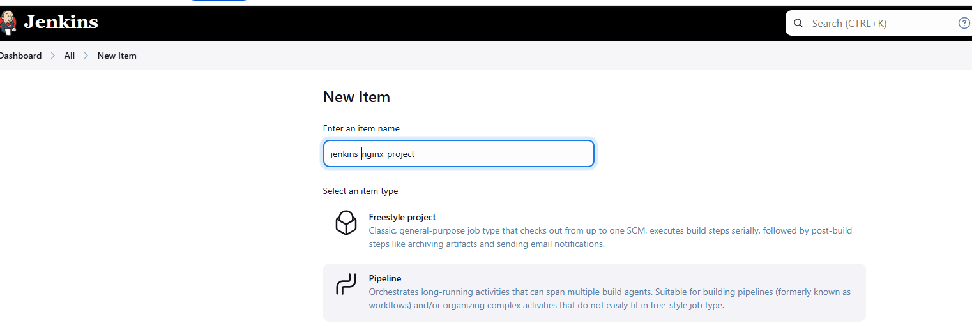](https://github.com/ikanko1989/jenkins-terraform-docker/blob/main/images/image002.png) [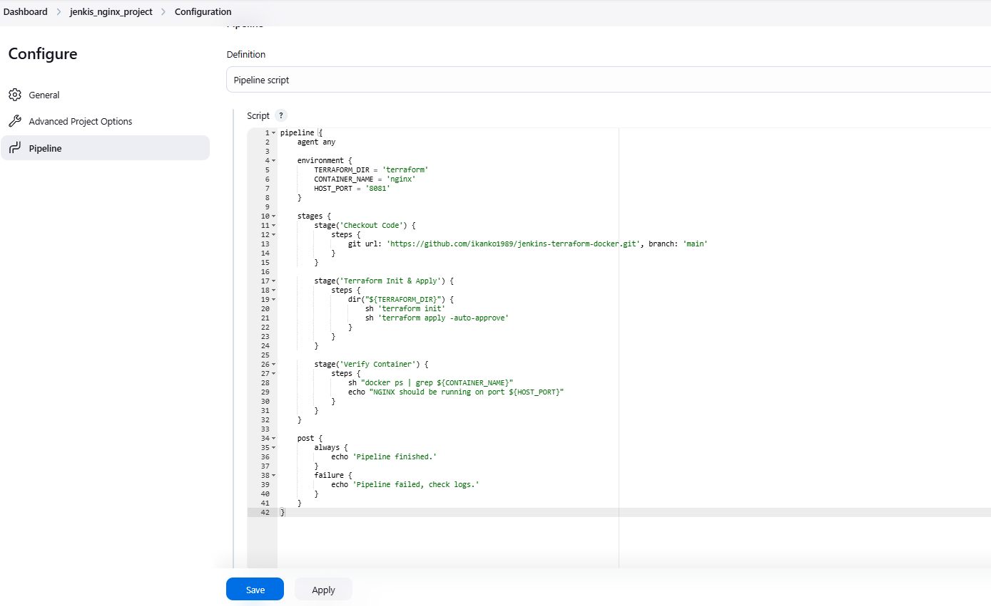](https://github.com/ikanko1989/jenkins-terraform-docker/blob/main/images/image009.png)

 [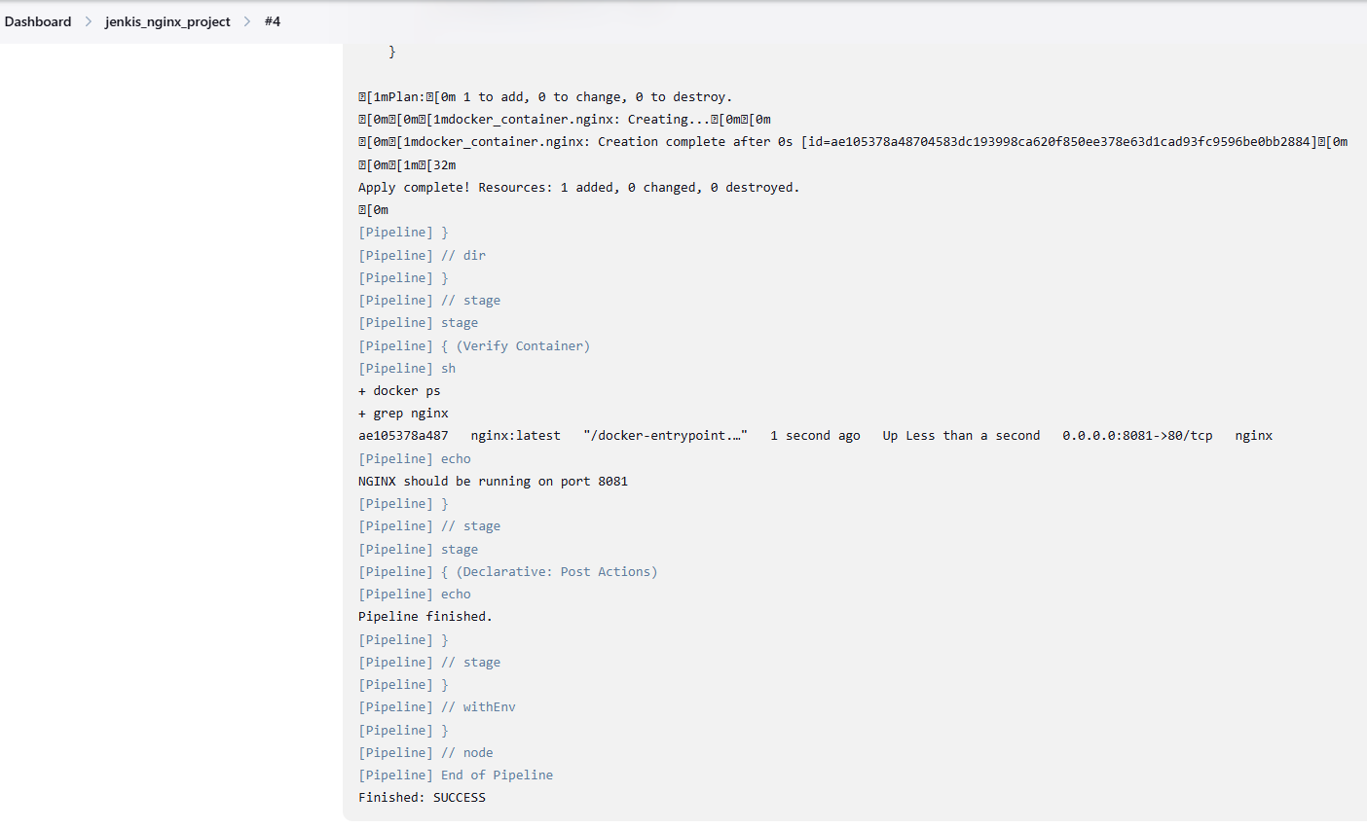](https://github.com/ikanko1989/jenkins-terraform-docker/blob/main/images/image013.png)

 [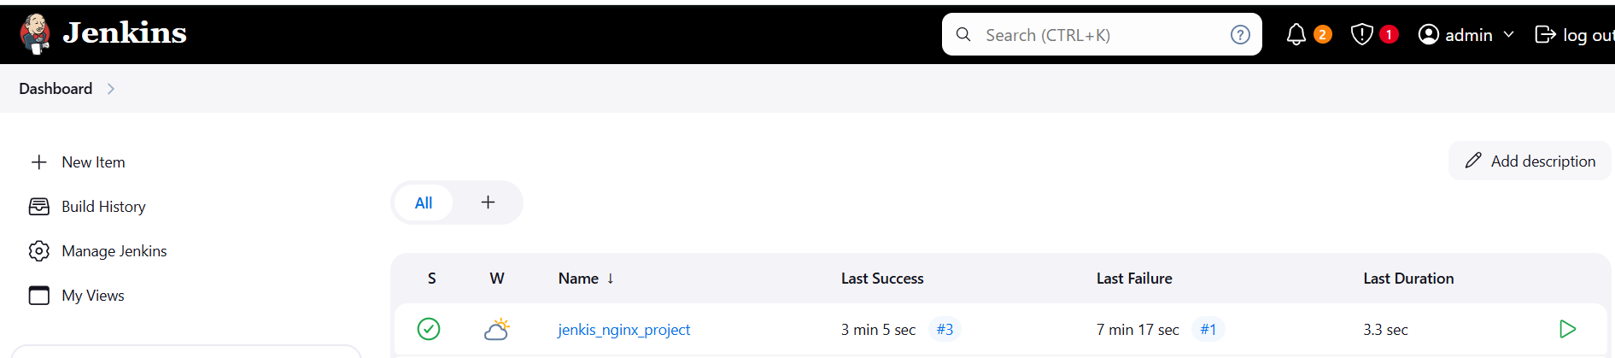](https://github.com/ikanko1989/jenkins-terraform-docker/blob/main/images/image005.png)

✅ **Checking state after pipeline was successfully completed:**

root@jenkins-server java/terraform on main via 💠 default ➜ pwd

/var/lib/jenkins/workspace/java/terraform

root@jenkins-server java/terraform on main via 💠 default ➜ terraform state list

docker_container.nginx

docker_image.nginx

root@jenkins-server java/terraform on main via 💠 default ➜ cat main.tf

terraform {

required_providers {

docker = {

source = "kreuzwerker/docker"

version = "~> 3.0.1"

}

}

}

✅ **NGINX container is up and running and accessed on port 8081:**

ADDITONAL CONTENT:

root@jenkins-server jenkis_nginx_project on  main ➜  ll

total 28

drwxr-xr-x 5 jenkins jenkins 4096 Aug 25 08:23  ./

drwxr-xr-x 7 jenkins jenkins 4096 Aug 25 08:21  ../

drwxr-xr-x 8 jenkins jenkins 4096 Aug 25 08:32  .git/

-rw-r--r-- 1 jenkins jenkins  953 Aug 25 08:23  Jenkinsfile

-rw-r--r-- 1 jenkins jenkins   52 Aug 25 08:19  README.md

drwxr-xr-x 3 jenkins jenkins 4096 Aug 25 08:32  terraform/

drwxr-xr-x 2 jenkins jenkins 4096 Aug 25 08:32 'terraform@tmp'/

root@jenkins-server jenkis_nginx_project/builds/4 ➜  ll

total 56

drwxr-xr-x 3 jenkins jenkins  4096 Aug 25 08:32 ./

drwxr-xr-x 6 jenkins jenkins  4096 Aug 25 08:32 ../

-rw-r--r-- 1 jenkins jenkins 20250 Aug 25 08:32 build.xml

-rw-r--r-- 1 jenkins jenkins     0 Aug 25 08:32 changelog1099963993225661366.xml

-rw-r--r-- 1 jenkins jenkins 17594 Aug 25 08:32 log

-rw-r--r-- 1 jenkins jenkins   108 Aug 25 08:32 log-index

drwxr-xr-x 2 jenkins jenkins  4096 Aug 25 08:32 workflow-completed/

root@jenkins-server ~/.terraform.d ➜  docker inspect 93102bc6f3de

[

    {

        "Id": "93102bc6f3de26f59e49161df720cd83f9f81e541f7e518210696ad6ad60fcb5",

        "Created": "2025-08-25T08:02:59.878474612Z",

        "Path": "/docker-entrypoint.sh",

        "Args": [

            "nginx",

            "-g",

            "daemon off;"

        ],

        "State": {

            "Status": "running",

            "Running": true,

            "Paused": false,

            "Restarting": false,

            "OOMKilled": false,

            "Dead": false,

            "Pid": 13987,

            "ExitCode": 0,

            "Error": "",

            "StartedAt": "2025-08-25T08:02:59.954899205Z",

            "FinishedAt": "0001-01-01T00:00:00Z"

        },

        "Image": "sha256:ad5708199ec7d169c6837fe46e1646603d0f7d0a0f54d3cd8d07bc1c818d0224",

        "ResolvConfPath": "/var/lib/docker/containers/93102bc6f3de26f59e49161df720cd83f9f81e541f7e518210696ad6ad60fcb5/resolv.conf",

        "HostnamePath": "/var/lib/docker/containers/93102bc6f3de26f59e49161df720cd83f9f81e541f7e518210696ad6ad60fcb5/hostname",

        "HostsPath": "/var/lib/docker/containers/93102bc6f3de26f59e49161df720cd83f9f81e541f7e518210696ad6ad60fcb5/hosts",

        "LogPath": "/var/lib/docker/containers/93102bc6f3de26f59e49161df720cd83f9f81e541f7e518210696ad6ad60fcb5/93102bc6f3de26f59e49161df720cd83f9f81e541f7e518210696ad6ad60fcb5-json.log",

        "Name": "/nginx",

        "RestartCount": 0,

        "Driver": "overlay2",

        "Platform": "linux",

        "MountLabel": "",

        "ProcessLabel": "",

        "AppArmorProfile": "",

        "ExecIDs": null,

        "HostConfig": {

            "Binds": null,

            "ContainerIDFile": "",

            "LogConfig": {

                "Type": "json-file",

                "Config": {}

            },

            "NetworkMode": "bridge",

            "PortBindings": {

                "80/tcp": [

                    {

                        "HostIp": "0.0.0.0",

                        "HostPort": "8081"

                    }

                ]

            },

            "RestartPolicy": {

                "Name": "no",

                "MaximumRetryCount": 0

            },

            "AutoRemove": false,

            "VolumeDriver": "",

            "VolumesFrom": null,

            "ConsoleSize": [

                0,

                0

            ],

            "CapAdd": null,

            "CapDrop": null,

            "CgroupnsMode": "host",

            "Dns": null,

            "DnsOptions": null,

            "DnsSearch": null,

            "ExtraHosts": null,

            "GroupAdd": null,

            "IpcMode": "private",

            "Cgroup": "",

            "Links": null,

            "OomScoreAdj": 989,

            "PidMode": "",

            "Privileged": false,

            "PublishAllPorts": false,

            "ReadonlyRootfs": false,

            "SecurityOpt": null,

            "UTSMode": "",

            "UsernsMode": "",

            "ShmSize": 67108864,

            "Runtime": "runc",

            "Isolation": "",

            "CpuShares": 0,

            "Memory": 0,

            "NanoCpus": 0,

            "CgroupParent": "",

            "BlkioWeight": 0,

            "BlkioWeightDevice": null,

            "BlkioDeviceReadBps": null,

            "BlkioDeviceWriteBps": null,

            "BlkioDeviceReadIOps": null,

            "BlkioDeviceWriteIOps": null,

            "CpuPeriod": 0,

            "CpuQuota": 0,

            "CpuRealtimePeriod": 0,

            "CpuRealtimeRuntime": 0,

            "CpusetCpus": "",

            "CpusetMems": "",

            "Devices": null,

            "DeviceCgroupRules": null,

            "DeviceRequests": null,

            "MemoryReservation": 0,

            "MemorySwap": 0,

            "MemorySwappiness": null,

            "OomKillDisable": false,

            "PidsLimit": null,

            "Ulimits": null,

            "CpuCount": 0,

            "CpuPercent": 0,

            "IOMaximumIOps": 0,

            "IOMaximumBandwidth": 0,

            "MaskedPaths": [

                "/proc/asound",

                "/proc/acpi",

                "/proc/kcore",

                "/proc/keys",

                "/proc/latency_stats",

                "/proc/timer_list",

                "/proc/timer_stats",

                "/proc/sched_debug",

                "/proc/scsi",

                "/sys/firmware",

                "/sys/devices/virtual/powercap"

            ],

            "ReadonlyPaths": [

                "/proc/bus",

                "/proc/fs",

                "/proc/irq",

                "/proc/sys",

                "/proc/sysrq-trigger"

            ],

            "Init": false

        },

        "GraphDriver": {

            "Data": {

                "LowerDir": "/var/lib/docker/overlay2/f663f3569b2e5f4d089bd32a407df13fb47df195b3c5a53ab12c8fb4b2bd8eb6-init/diff:/var/lib/docker/overlay2/80a8cfb2ab2b829e0d587b02826762b8a451ed255602e152d7969e0585bb1200/diff:/var/lib/docker/overlay2/545b209a39232b47fbc49a058f866965ca32162444aa6afe689663d866edc597/diff:/var/lib/docker/overlay2/04c285a991ae74615682fdb4549a3a3f0985e47e340812d44cfe99ece3bb818a/diff:/var/lib/docker/overlay2/f1f23d36132150bcdd99f35fa3766631c623aa580867805118a6c2910a248af2/diff:/var/lib/docker/overlay2/eb1ec91acdd089c8c88dafee295fcfebaa1a9f4d0b8a74f989f372a27f2620f0/diff:/var/lib/docker/overlay2/7e2a97767292834519370dbbdd68b252bfb0e4a8240174ef9433fdf29122ae90/diff:/var/lib/docker/overlay2/b8e8620106af135872a1f35791e1511cad4fef5bcbe80fbb0db97946edc2f565/diff",

                "MergedDir": "/var/lib/docker/overlay2/f663f3569b2e5f4d089bd32a407df13fb47df195b3c5a53ab12c8fb4b2bd8eb6/merged",

                "UpperDir": "/var/lib/docker/overlay2/f663f3569b2e5f4d089bd32a407df13fb47df195b3c5a53ab12c8fb4b2bd8eb6/diff",

                "WorkDir": "/var/lib/docker/overlay2/f663f3569b2e5f4d089bd32a407df13fb47df195b3c5a53ab12c8fb4b2bd8eb6/work"

            },

            "Name": "overlay2"

        },

        "Mounts": [],

        "Config": {

            "Hostname": "93102bc6f3de",

            "Domainname": "",

            "User": "",

            "AttachStdin": false,

            "AttachStdout": false,

            "AttachStderr": false,

            "ExposedPorts": {

                "80/tcp": {}

            },

            "Tty": false,

            "OpenStdin": false,

            "StdinOnce": false,

            "Env": [

                "PATH=/usr/local/sbin:/usr/local/bin:/usr/sbin:/usr/bin:/sbin:/bin",

                "NGINX_VERSION=1.29.1",

                "NJS_VERSION=0.9.1",

                "NJS_RELEASE=1~bookworm",

                "PKG_RELEASE=1~bookworm",

                "DYNPKG_RELEASE=1~bookworm"

            ],

            "Cmd": [

                "nginx",

                "-g",

                "daemon off;"

            ],

            "Image": "nginx:latest",

            "Volumes": null,

            "WorkingDir": "",

            "Entrypoint": [

                "/docker-entrypoint.sh"

            ],

            "OnBuild": null,

            "Labels": {

                "maintainer": "NGINX Docker Maintainers [docker-maint@nginx.com](mailto:docker-maint@nginx.com)"

            },

            "StopSignal": "SIGQUIT"

        },

        "NetworkSettings": {

            "Bridge": "",

            "SandboxID": "b17d6f36c569d4508d8ff5c25af5e3257da10524ee3eba4649cb6680594b6c1f",

            "SandboxKey": "/var/run/docker/netns/b17d6f36c569",

            "Ports": {

                "80/tcp": [

                    {

                        "HostIp": "0.0.0.0",

                        "HostPort": "8081"

                    }

                ]

            },

            "HairpinMode": false,

            "LinkLocalIPv6Address": "",

            "LinkLocalIPv6PrefixLen": 0,

            "SecondaryIPAddresses": null,

            "SecondaryIPv6Addresses": null,

            "EndpointID": "d44c71b9139dfe0dfc54267b0b937497eb44cc540574363e3913dc397984f6de",

            "Gateway": "172.12.0.1",

            "GlobalIPv6Address": "",

            "GlobalIPv6PrefixLen": 0,

            "IPAddress": "172.12.0.2",

            "IPPrefixLen": 24,

            "IPv6Gateway": "",

            "MacAddress": "02:42:ac:0c:00:02",

            "Networks": {

                "bridge": {

                    "IPAMConfig": null,

                    "Links": null,

                    "Aliases": null,

                    "MacAddress": "02:42:ac:0c:00:02",

                    "DriverOpts": null,

                    "NetworkID": "aabfe5ef88613d607dcc12d040b5f51bf5df6e2f0fb2b0a39f6ef79f43e613f3",

                    "EndpointID": "d44c71b9139dfe0dfc54267b0b937497eb44cc540574363e3913dc397984f6de",

                    "Gateway": "172.12.0.1",

                    "IPAddress": "172.12.0.2",

                    "IPPrefixLen": 24,

                    "IPv6Gateway": "",

                    "GlobalIPv6Address": "",

                    "GlobalIPv6PrefixLen": 0,

                    "DNSNames": null

                }

            }

        }

    }

]

root@jenkins-server java/terraform on  main via 💠 default ➜  cat terraform.tfstate

{

  "version": 4,

  "terraform_version": "1.13.0",

  "serial": 9,

  "lineage": "783e5f3d-79b3-d663-a03b-17f147951b03",

  "outputs": {},

  "resources": [

    {

      "mode": "managed",

      "type": "docker_container",

      "name": "nginx",

      "provider": "provider[\"[registry.terraform.io/kreuzwerker/docker\](http://registry.terraform.io/kreuzwerker/docker%5C)"]",

      "instances": [

        {

          "schema_version": 2,

          "attributes": {

            "attach": false,

            "bridge": "",

            "capabilities": [],

            "cgroupns_mode": null,

            "command": [

              "nginx",

              "-g",

              "daemon off;"

            ],

            "container_logs": null,

            "container_read_refresh_timeout_milliseconds": 15000,

            "cpu_set": "",

            "cpu_shares": 0,

            "destroy_grace_seconds": null,

            "devices": [],

            "dns": null,

            "dns_opts": null,

            "dns_search": null,

            "domainname": "",

            "entrypoint": [

              "/docker-entrypoint.sh"

            ],

            "env": [],

            "exit_code": null,

            "gpus": null,

            "group_add": null,

            "healthcheck": null,

            "host": [],

            "hostname": "93102bc6f3de",

            "id": "93102bc6f3de26f59e49161df720cd83f9f81e541f7e518210696ad6ad60fcb5",

            "image": "sha256:ad5708199ec7d169c6837fe46e1646603d0f7d0a0f54d3cd8d07bc1c818d0224",

            "init": false,

            "ipc_mode": "private",

            "labels": [],

            "log_driver": "json-file",

            "log_opts": null,

            "logs": false,

            "max_retry_count": 0,

            "memory": 0,

            "memory_swap": 0,

            "mounts": [],

            "must_run": true,

            "name": "nginx",

            "network_data": [

              {

                "gateway": "172.12.0.1",

                "global_ipv6_address": "",

                "global_ipv6_prefix_length": 0,

                "ip_address": "172.12.0.2",

                "ip_prefix_length": 24,

                "ipv6_gateway": "",

                "mac_address": "02:42:ac:0c:00:02",

                "network_name": "bridge"

              }

            ],

            "network_mode": "bridge",

            "networks_advanced": [],

            "pid_mode": "",

            "ports": [

              {

                "external": 8081,

                "internal": 80,

                "ip": "0.0.0.0",

                "protocol": "tcp"

              }

            ],

            "privileged": false,

            "publish_all_ports": false,

            "read_only": false,

            "remove_volumes": true,

            "restart": "no",

            "rm": false,

            "runtime": "runc",

            "security_opts": [],

            "shm_size": 64,

            "start": true,

            "stdin_open": false,

            "stop_signal": "SIGQUIT",

            "stop_timeout": 0,

            "storage_opts": null,

            "sysctls": null,

            "tmpfs": null,

            "tty": false,

            "ulimit": [],

            "upload": [],

            "user": "",

            "userns_mode": "",

            "volumes": [],

            "wait": false,

            "wait_timeout": 60,

            "working_dir": ""

          },

          "sensitive_attributes": [],

          "identity_schema_version": 0,

          "private": "eyJzY2hlbWFfdmVyc2lvbiI6IjIifQ==",

          "dependencies": [

            "docker_image.nginx"

          ]

        }

      ]

    },

    {

      "mode": "managed",

      "type": "docker_image",

      "name": "nginx",

      "provider": "provider[\"[registry.terraform.io/kreuzwerker/docker\](http://registry.terraform.io/kreuzwerker/docker%5C)"]",

      "instances": [

        {

          "schema_version": 0,

          "attributes": {

            "build": [],

            "force_remove": null,

            "id": "sha256:ad5708199ec7d169c6837fe46e1646603d0f7d0a0f54d3cd8d07bc1c818d0224nginx:latest",

            "image_id": "sha256:ad5708199ec7d169c6837fe46e1646603d0f7d0a0f54d3cd8d07bc1c818d0224",

            "keep_locally": null,

            "name": "nginx:latest",

            "platform": null,

            "pull_triggers": null,

            "repo_digest": "nginx@sha256:33e0bbc7ca9ecf108140af6288c7c9d1ecc77548cbfd3952fd8466a75edefe57",

            "triggers": null

          },

          "sensitive_attributes": [],

          "identity_schema_version": 0,

          "private": "bnVsbA=="

        }

      ]

    }

  ],

  "check_results": null

}

root@jenkins-server java/terraform on  main via 💠 default ➜  terraform state list

docker_container.nginx

docker_image.nginx